Shed Your Bed Challenge
What is the Challenge?
Habitat Ireland are asking you to experience what it is like to not have a safe, decent place to live. Somewhere without a warm comfortable bed to sleep in, by asking you to ‘shed your bed’ for one night and get sponsorship for doing so.

Why take on the Challenge?
Globally 1.8 million people live in inadequate shelter and 100 million do not have any shelter at all. The Shed your bed challenge is a great way to raise awareness of this issue while also helping raise important funds to create a word where everyone has a decent place to live.

How to complete the challenge?
All you need to complete the challenge is:
- To register with Habitat Ireland
- Somewhere other than your bed to sleep in
- Decide if you would like to do it on your own or with your friends or family.
- To tell everyone about the event and encourage lots of support!
- Share your story, send info and maybe even some photos with us, don’t forget to tag @habitatforhumanityireland or email to communications@habitatireland.org
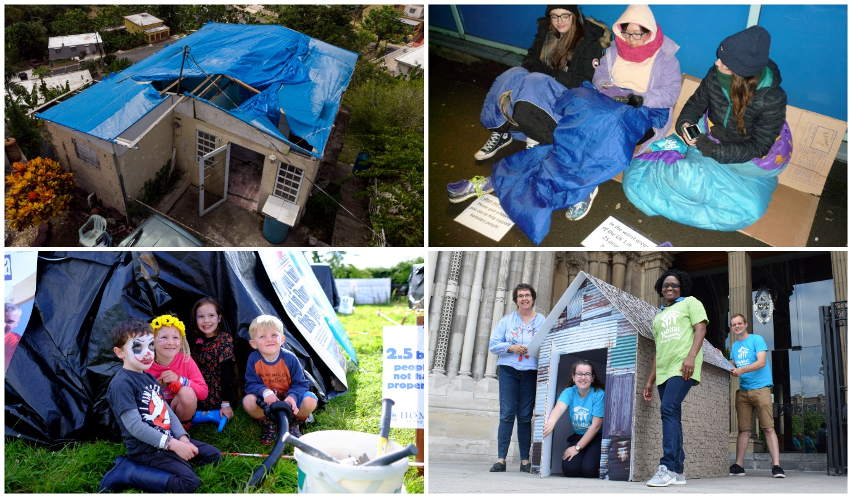
All participants will receive a certificate on completion of the challenge, from Habitat Ireland.

