Yana – Ukrainian refugees

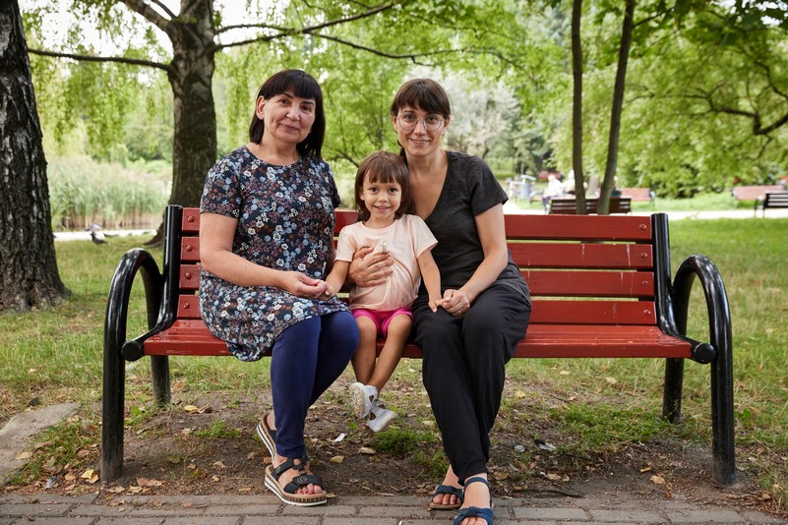
A few months ago, life for Yana, her mum Lily and daughter Marta changed dramatically as war broke out in the country they called home, Ukraine. Forced from their home like almost one third of the country’s population, they fled Ukraine. Life was not easy, as they moved from temporary accommodation to temporary accommodation. This instability was further complicated by Marta’s autism and Lily’s terminal cancer, forcing the family to consider an early return to Ukraine.

With Habitat Poland’s support, Yana changed her mind. “They took us to an apartment — just for us. I was in shock,” she said. Habitat volunteers brought pots and pans, dishes, blankets, personal hygiene products and a new mattress. That made her family happy, Yana said.

Habitat for Humanity has provided up to 10,000+ refugees with shelter services at the border and continues to support those who fled from the war. You can read more on Habitat’s Ukraine crisis response on the website: www.habitatireland.org/ukraine

Questions:
- Who was in the story?
Yana, Lily and Martha
- Where are they from?
Ukraine
- Where are the family now?
Poland
- What are some of the issues facing the family?
The family were fleeing the war in Ukraine. Living in temporary accommodation. No basic possessions. No stability. Health issues. Disruption to normal life/ routine especially difficult for Martha who has autism.
- How has Habitat helped their lives improve?
Safe, secure home with all the necessary basics for living, just for them. Somewhere the family can stay for as long as is needed. Stability.

